SKILLS

M.SC BIOTECHNOLOGY G.U

B.SC ZOOLOGY HONS.
HIGHER SECONDARY
2010 - 2012

KRISHNENDU DEY

2013 - 2016

2011 - 2014

GAUHATI UNIVERSITY
AHSEC
Guwahati
Guwahati
Guwahati
Guwahati
English
Hindi

Genetics
Biochemistry
Microbiology
Cell Biology
Guwahati
LANGUAGES KNOWN

GRAPHIC & WEB DESIGN/ CONTENT EDITING

Written English

English Grammar
Html/CSS/Photoshop

Overall CGPA: 6.2 [Medium English]
M.SC BIOTECHNOLOGY
2008

WORK EXPERIENCE

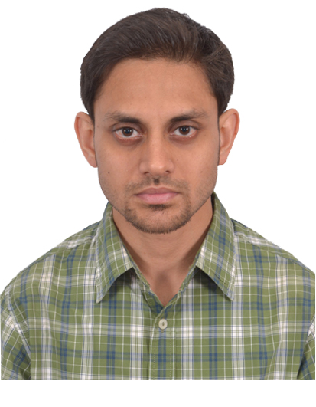
2007 - 2010

Overall 62% with Distinction** [Medium English]
Stream Science; Medium English; Overall 61%
WHY ME?

EDUCATION

I crave for sharing my ‘knowledge’
and have been recently searching for
a “tool” to spread it.

Biology is my favorite subject as it the essence of “life.” I am a Masters in Biotechnology. Additionally, written English and English Grammar are my strengths.

Though I am yet to contribute to the field of Biology & Biotechnology, yet writing & editing is my dream & passion and I am optimistic that I can unleash the best in me.

GAUHATI UNIVERSITY

Life Sciences
Biotechnology

COACHING & TUTIONS
Photoshop Designing, Website Designing on Magento & Wordpress, Content Writing for Blogs, Websites, Freelance Writing and Editing in Life Science related materials. Online Marketing, Global Live Support.
Green India Publication & Technologies
[Self-Owned Partnership Firm]
Private coaching and tuitions for classes 9 and 10
in Science [Biology] and English Grammar.
CONTACTS & PERSONAL DETAILS

Freelancer
+91-94357-03692; +91-81359-92270

krishnendu4august@gmail.com; info.mageorange@gmail.com

Father: Late Parimal Chandra Dey;
Mother: Smt. Dipali Dey;
Sex: Male;
Marital Status: Unmarried;
Religion: Hinduism;
Mother Tongue: Bengali;
Date of Birth: 4th August, 1985;
Hobbies: Writing, Travelling, Music, Gaming, Technology, Watching Documentaries, Knowledge, Biology etc.

JOB OBJECTIVE
Sharing knowledge has always been my favorite pastime so taking up this as my profession will certainly bring out the best in me.

DECLARATION:

I, hereby, declare that the information furnished above is true to the best of my knowledge.

Place: Guwahati- ASSAM, INDIA Yours faithfully,
Date: 10th of October, 2016.

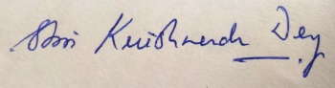

(KRISHNENDU DEY)

